Taylor Arnold (Wolff)

Week 2 – VBA Challenge

UCI Irvine – Data Analytic Bootcamp

Instructor - Chris Shoe

September 22, 2020

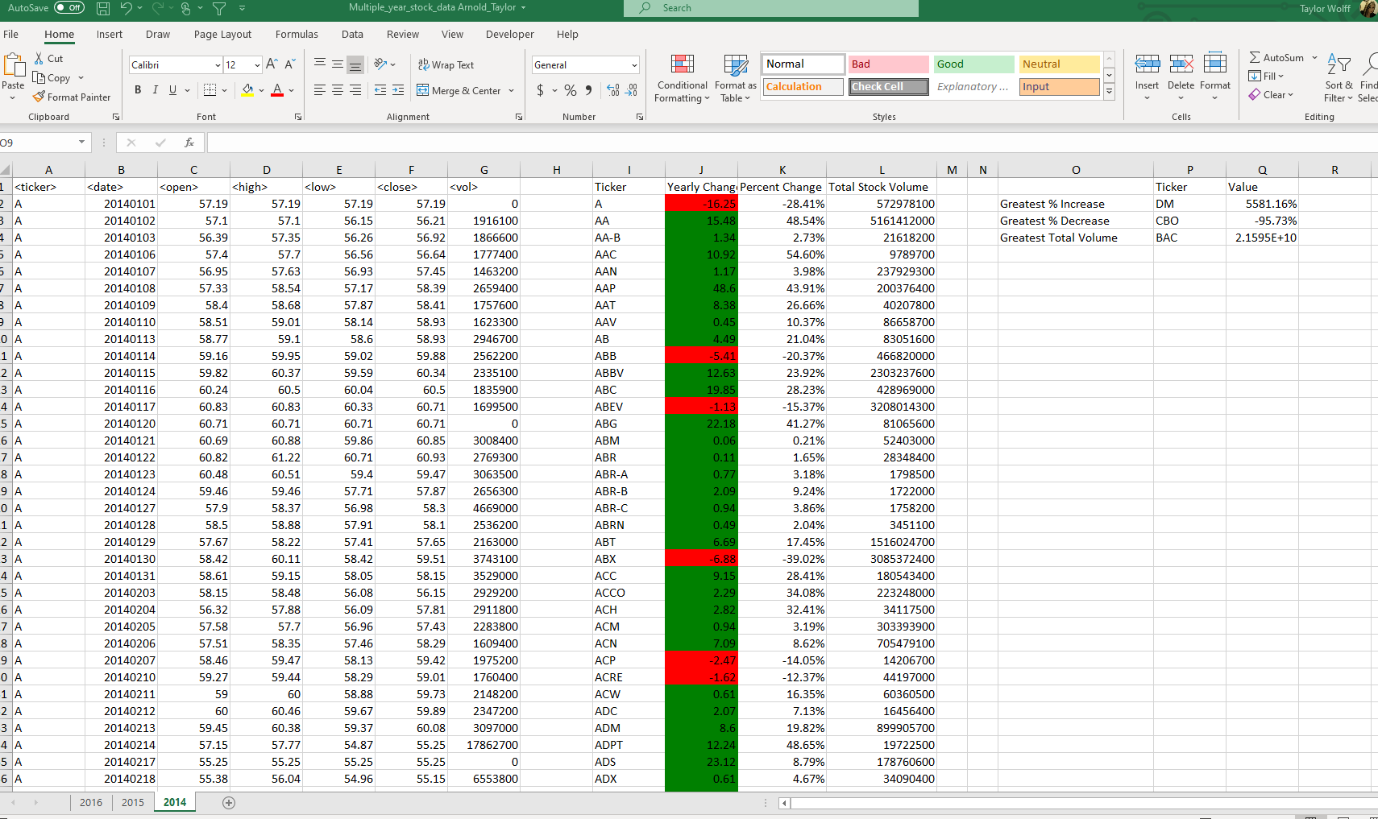

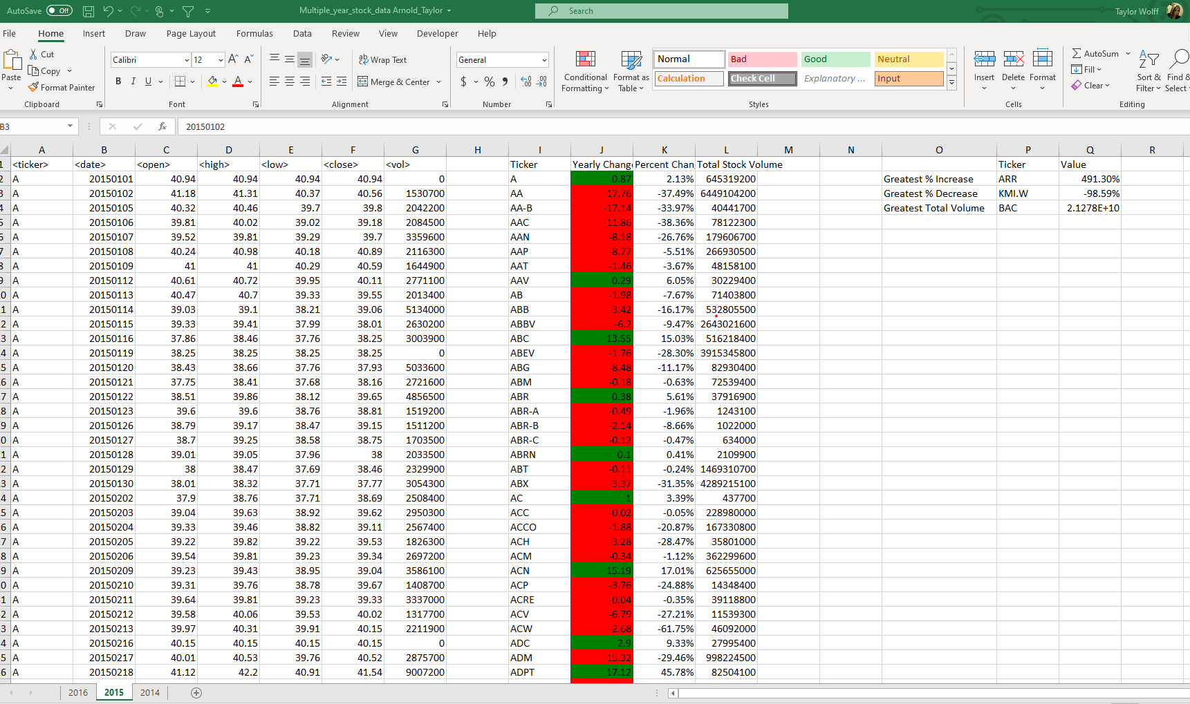

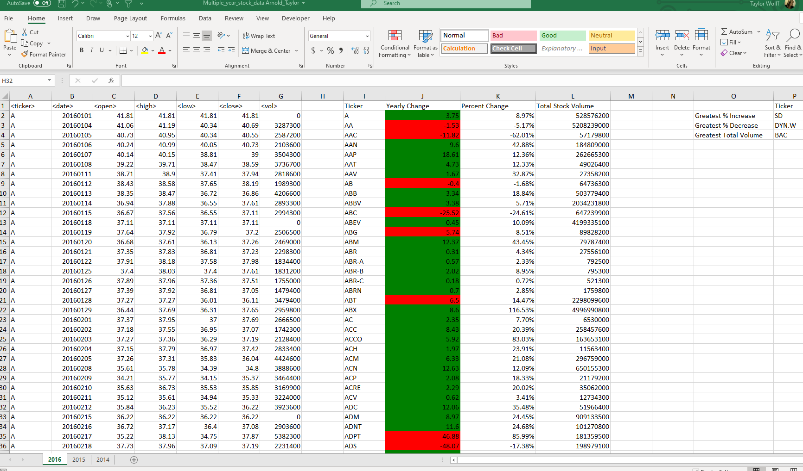

References

*VBA Max Function: How to Find Maximum Using Max in Excel VBA?* WallStreetMojo. (2020, July 16). https://www.wallstreetmojo.com/vba-max/.